NAME

Southern Cross College

Level 1 Economics, 2013

Mid-Year Examinations

90983 Demonstrate understanding of consumer choices, using scarcity and/or demand

Practice Credits: Four

Achievement | Achievement with Merit | Achievement with Excellence
- Demonstrate understanding of consumer choices, using scarcity and/or demand. | - Demonstrate in-depth understanding of consumer choices, using scarcity and/or demand. | - Demonstrate comprehensive understanding of consumer choices, using scarcity and/or demand.

You should answer all questions in this booklet.

If you need more space for any answer, use the page(s) provided at the back of this booklet and clearly number the question.

Check that this booklet has pages 1 – 8 in the correct order and that none of these pages is blank.

YOU MUST HAND THIS BOOKLET TO THE SUPERVISOR AT THE END OF THE EXAMINATION

Total
Assessors use only
QUESTION ONE: SCARICTY

Richard lives with his parents. He works part time at the local supermarket. The following are the main activities he chooses to spend his time on.

- Attend gym twice a week
- Spend time in the library
- Work part time in the local fruit & vegetable store
- Spend time with cousins

Complete (a) and (b) to fully explain how scarcity and values affect consumer choices.

- Explain how time is a limited resource for Richard. In your answer, you should refer to the resource material above and discuss:

• scarcity
• choice
• opportunity cost

- Fully explain the way values might influence how Richard chooses to spend his time. In your answer, you should refer to the main activities on page 2 that Richard chooses to spend his time on, and discuss:

• the most likely activity Richard will spend his time doing if he values his health
• the most likely activity Richard will spend his time doing if he values financial stability
• conflict that might arise over the two decisions above
• TWO ways Richard may use to resolve this conflict.

QUESTION TWO: the law of demand

Fiana buys bags of sweets on her way home from school. She usually buys four bags per week when they are $2 each. If they were $1 each she would buy seven bags in a week. When they were $1.50 per bag she five bags during the week.

- Draw Fiana’s weekly demand curve for sweets on the graph below. Fully label the graph.

Title

- On the graph above, show the effect of the price of sweets increasing from $1.50 to $2.00. Fully label the graph.

(c) Discuss the change in the number of bags of sweets that Fiana buys as the price of each bag rises from $1.00 to $2.00.

In your answer you should:
• refer to the Law of Demand using data from previous page
• give reasons for the change in the number of bags of sweets that Fiana buys
• fully explain TWO flow-on effects this price change may have for Fiana.

QUESTION THREE: PRICE OF OTHER GOODS AND SERVICES

Fiana’s school is organising Zumba lessons on Thursdays after school at a cheaper price than her gym fees which she also attends on the Thursdays.
Discuss how cheaper Zumba lessons will affect Fiana’s demand for gym sessions.
In your answer, you should:
• explain the economic term that best describes the relationship between Zumba lessons and gym sessions for Fiana
• show changes in the sketch graphs below, and refer to them in your explanation
• fully explain TWO flow-on effects this change in demand may have for Fiaina.

Fiana’s demand for Zumba lessons Fiana’s demand for Gym sessions

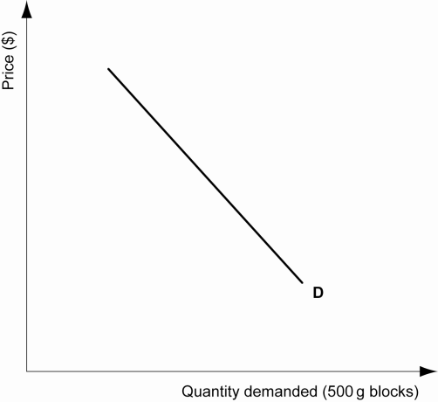  Quantity | Quantity

QUESTION FOUR

Boris often eats baked beans on toast for tea. His brother, Alex, has graduated from university and has a job as an engineer. Alex dines out at restaurants twice a week.
- Fully explain the impact that increased levels of income have on the demand for luxuries, necessities and inferior goods. In your answer you should:
- explain what luxuries, necessities and inferior goods are, including examples
- explain the effect of increased income levels on the demand for each type of good (luxury, necessity, inferior)
- refer to the resource material above in your answer

