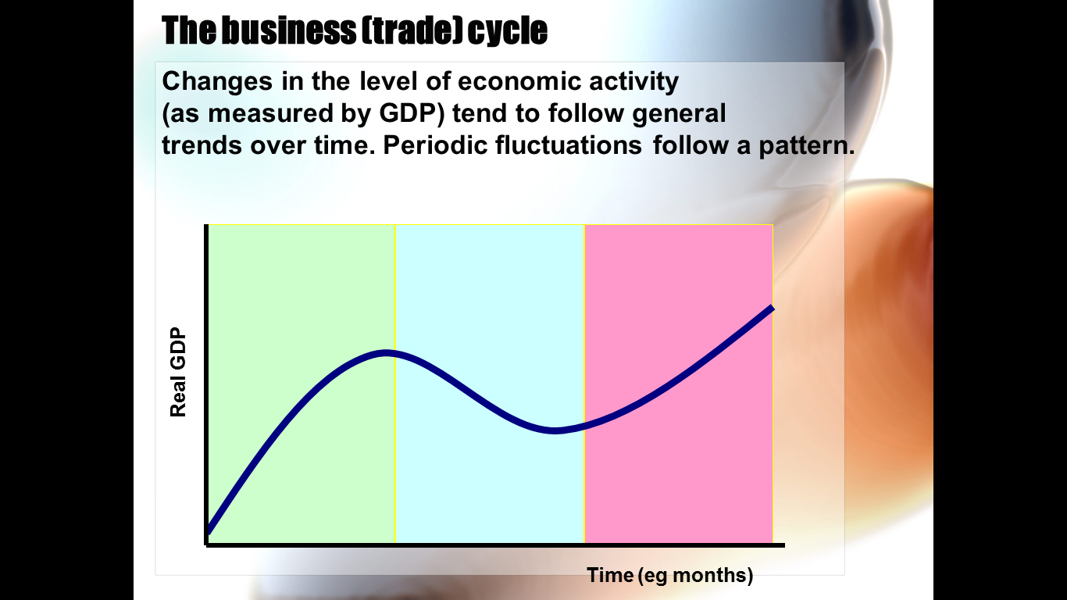

Upswing/ Recovery

**Depression**

Downswing/Recession

Peak/Boom

Upswing

