Educating Young People Who Will Be
2
Significantly Different!

SOUTHERN CROSS COLLEGE

NAME CLASS

Level 2 Economics
91223 (2.2): Analyse international trade using economic
concepts and models

Credits: Four

You should answer ALL parts of ALL questions in this booklet.

If you need more space for any answer, use the page(s) provided at the back of this booklet and clearly number the question.

Check that this booklet has pages 2–11 in the correct order and that none of these pages is blank.

YOU MUST HAND THIS BOOKLET TO YOUR TEACHER AT THE END OF THE ALLOTTED TIME.

You are advised to spend 60 minutes answering the questions in this booklet.

QUESTION ONE: balance on goods and services

NZ's trade surplus continues to dwindle
The annual trade surplus continued to shrink last month and economists expect the trend to continue…... Goldman Sachs economist Philip Borkin said that as the combined effect of lower commodity prices, a high dollar and weaker trading partner growth weighed on the trade balance
Source: NZ's trade surplus continues to dwindle, The New Zealand Herald, Tuesday Mar 27, 2012, http://www.nzherald.co.nz/business/news/article.cfm?c_id=3&objectid=10794777

- State the current account balance in which sales of milk powder to China would be classified.

- Give a detailed explanation of the impact of trading partners experiencing a recession on
New Zealand’s Balance of Goods and Services.

With the loss in confidence in the US and European economies, the New Zealand dollar has become popular for currency traders, resulting in the New Zealand Dollar becoming the 8th most traded currency internationally.

- Show the effect of the increasing popularity of the $NZ on the foreign exchange market
Graph One: Market for the New Zealand dollar
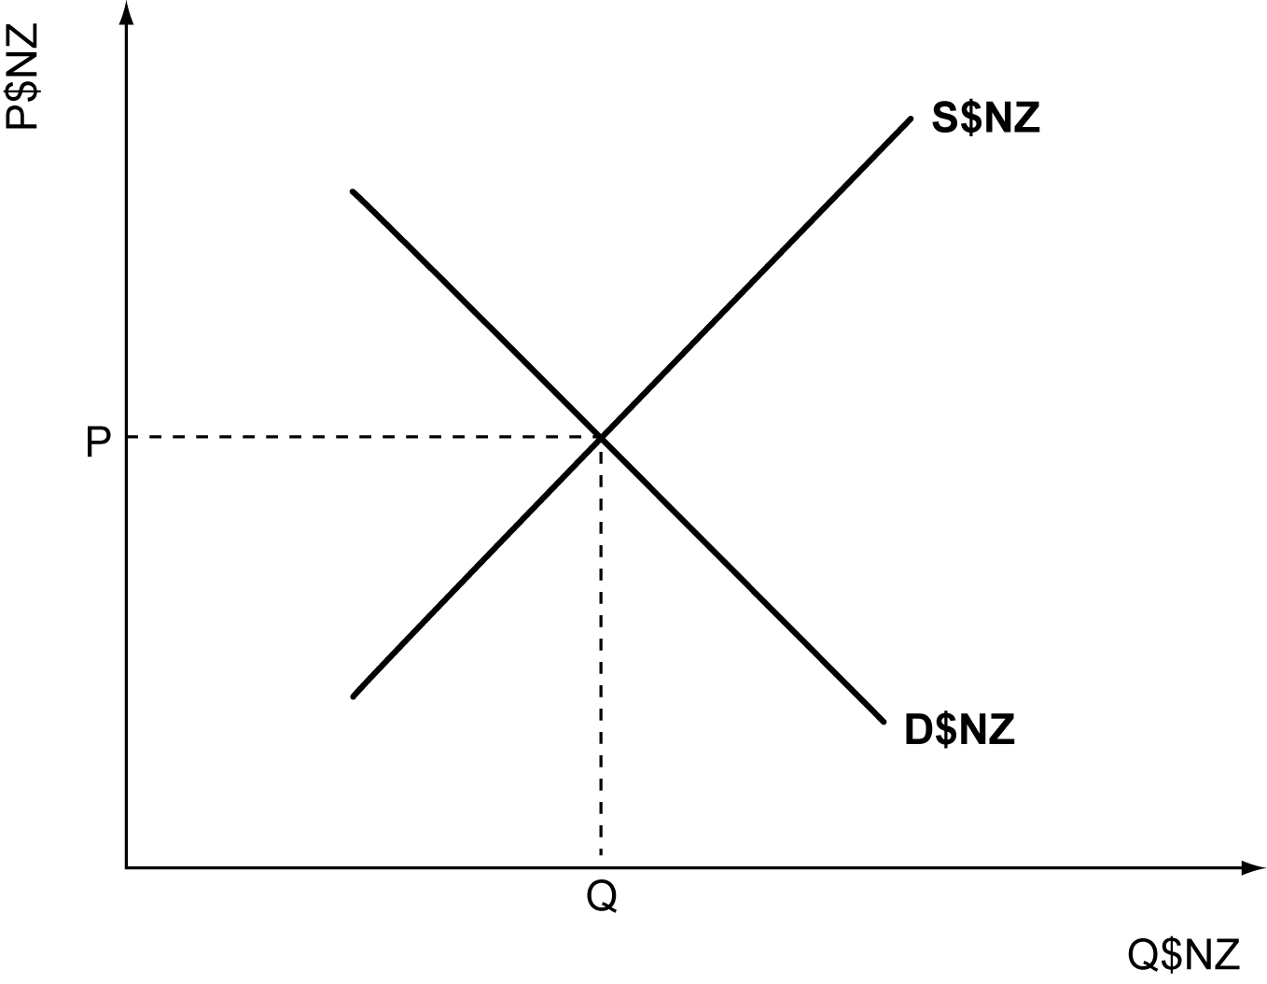
- Compare and contrast the effects of a higher exchange rate to our trading partners experiencing a recession on New Zealand’s Balance of Goods and Services. In your answer, you should:
explain in detail how an increase in the value of the New Zealand dollar impacts on New Zealand’s Balance of Goods and Services.
explain in detail why an increase in the value of the New Zealand dollar may have a greater effect on New Zealand’s Balance of Goods and Services than weaker trading partner growth.

QUESTION two: new zealand exports and the one country model

NZ's trade surplus continues to dwindle
support for the export sector is likely to moderate ... particularly as global commodity prices for New Zealand's exports ease back from very elevated levels."
Source: NZ's trade surplus continues to dwindle, The New Zealand Herald, Tuesday Mar 27, 2012, http://www.nzherald.co.nz/business/news/article.cfm?c_id=3&objectid=10794777

- Graph TWO below shows the New Zealand market for Milk Powder. Explain in detail why New Zealand would be an exporter in this market

Graph TWO: One country model with New Zealand as a price taker
New Zealand market for Milk Powder

Price
D
S

Sw

Quantity

- On Graph TWO above show the effect of falling world prices for Milk Powder, and use the label X1 to show the new level of exports.

- Analyse the different impact of falling world prices for dairy products on various groups. In your answer, you should compare and contrast the effects of falling world prices for dairy products:
between New Zealand milk powder exporters and the firms producing dairy based products for the domestic market.
between consumers and employees

QUESTION THree: new zeland imports and the two country model

Big wet to spur bumper crops
"Australian grain production may be set for another bumper crop in 2012-13, with wheat production forecast to reach 24.7 million tonnes
Source: Business Big wet to spur bumper crops - Weekly Times Now, April 10 2012,
http://www.weeklytimesnow.com.au/article/2012/04/10/467805_business-news.html

- State TWO of the top four countries that New Zealand imports from.

- On Graph THREE show the new level of imports and the new world price for the New Zealand wheat market if there was an increase in supply of wheat in the Australian wheat market. Use the labels M and P_{w1}.
Graph THREE: Two country model
New Zealand wheat market | Australian wheat market
Quantity
Price
D
Price
S

S

Pw

D

Quantity

- Give a detailed explanation of what would happen to New Zealand wheat growers’ profits as a result of the changes you made in (b).

- Compare and contrast the effect on New Zealand wheat growers’ profits of an increase in New Zealand supply for wheat with an increase in the Australian supply of wheat. In your answer, you should:
explain in detail the effect of an increase in the New Zealand supply of wheat on the profits of New Zealand wheat growers
explain in detail whether an increase in Australian supply of wheat or an increase in the New Zealand supply of wheat would have a greater effect on the profits of New Zealand wheat growers
show the effect of an increase in the New Zealand supply of wheat in Graph FOUR below to support your answer.

Graph FOUR: Two country model
New Zealand wheat market  Quantity  Price  D  S  Quantity  Price  D  S | Australian wheat market
Pw

QUESTION four: trade barriers

- State TWO of the top four categories of commodities that New Zealand exports

No govt action over Tasmanian rejection of NZ apples
The island state is holding out against the imports despite a World Trade Ruling rejecting Australia's 90-year ban on Kiwi apples, and Biosecurity Australia's final approval (of allowing apple imports from New Zealand) last August.
Source: No govt action over Tasmanian rejection of NZ apples – The NZ Herald, Jan 29, 2012, http://www.nzherald.co.nz/nz/news/article.cfm?c_id=1&objectid=10782012

- Explain how the Tasmanian trade restrictions would affect the profits of New Zealand apple growers.

- Analyse the different impact of Tasmania’s trade restrictions on various groups. In your answer, you should compare and contrast the effect of Tasmania’s trade restrictions, taking into account any differences if New Zealand is a price taker or not in the world apple market:
between consumers in New Zealand and Tasmania
between apple growers in New Zealand and Tasmania

Extra paper for continuing your answers, if required.
Clearly number the question.
Question
number

