**Task sheet 1 - Positive and Negative Externalities (Test Conditions)**

NAME: ___________________________________________

For each graph below

[i] label the unregulated/free market price and quantity as Pp and Qp respectively

[ii] add the appropriate Social Marginal Cost or Benefit curve to illustrate the situation given

[iii] label the social price and quantity.

|  |  |
| --- | --- |
| **[a] Negative externality of production** | **[b] Positive externality of production** |
| 0 Quantity    MC, MB    MB  MC | 0 Quantity    MC, MB    MB  MC |
| **[c] Negative externality of consumption**  0 Quantity    MC, MB    MB  MC | **[d] Positive externality of consumption**  0 Quantity    MC, MB    MB  MC |

2. Complete the following sentences

Goods with negative externalities of production are ________ produced and ________ priced.

Goods with positive externalities of production are ________ produced and ________ priced.

Goods with negative externalities of consumption are ________ produced and ________ priced.

Goods with positive externalities of consumption are ________ produced and ________ priced.

**Task sheet 2 - Positive and Negative Externalities of Consumption and Production**

For each graph below

[i] label the unregulated or free market price and quantity as **Pp** and **Qp** respectively

[ii] add the appropriate Social Marginal Cost or Benefit curve to illustrate the situation given

[iii] label the **social price** and **social quantity**

[iv] shade in the social **deadweight loss**

[v] suggest a Government intervention for the externality

|  |  |
| --- | --- |
| **1. A steel factory emits pollutants into the atmosphere** | **2. Flu vaccinations for the winter** |
| 0 Quantity    MC, MB    MB  MC | 0 Quantity    MC, MB    MB  MC |
| Suggested Government intervention  ______________________________________ | Suggested Government intervention  ______________________________________ |
|  |  |
| **3. A bee keeper living in a fruit orchard area decides to increase his number of bees in order to make more honey.** | **4. Teenagers consuming RTDs** |
| 0 Quantity    MC, MB    MB  MC | 0 Quantity    MC, MB    MB  MC |
| Suggested Government intervention  ______________________________________ | Suggested Government intervention  ______________________________________ |

**Task sheet 3 - Government Interventions - Positive and Negative Externalities**

For each situation below

[i] label the unregulated or free market price and quantity as **Pp** and **Qp** respectively

[ii] add the appropriate **Social Marginal Cost/Benefit** curve and label the **social price** and **quantity**

[iii] think of a Government intervention or policy for the externality and show the effects of this on

the graph.

[iv] explain the changes you made to the graph.

[v] explain the effect of this intervention on the efficiency [*i.e. effect on price, quantity, social*

*cost/benefit and social deadweight loss]*

1.  **Fertiliser used by Dairy farmers pollutes local rivers.**

Market for Dairy Products

0 Quantity

MC, MB

MB

MC

|  |
| --- |
| Government Intervention: |
|  |
| Explain the changes to your diagram as a result of the Government Intervention: |
|  |
|  |
|  |
|  |
|  |
| Explain the effect of the Government intervention/policy on efficiency: *[i.e. explain the effect of the policy on effect on price, quantity, social cost/benefit and social deadweight loss]* |
|  |
|  |
|  |
|  |
|  |
|  |
|  |
|  |
|  |
|  |
|  |
|  |
|  |
|  |
|  |
|  |
|  |
|  |
|  |
|  |
|  |
|  |
|  |

2. **Increased consumption of takeaway food increases obesity**

Market for Takeaway Food

0 Quantity

MC, MB

MB

MC

|  |
| --- |
| Government Intervention: |
|  |
| Explain the changes to your diagram as a result of the Government Intervention: |
|  |
|  |
|  |
|  |
|  |
| Explain the effect of the Government intervention/policy on efficiency: *[i.e. explain the effect of the policy on effect on price, quantity, social cost/benefit and social deadweight loss]* |
|  |
|  |
|  |
|  |
|  |
|  |

**Task sheet 4- Externalities**

**Complete the following graphic organiser template using ‘Scenario 1’.**

Externality: *[explain the externality that exists]*

Externality Diagram: *[show the externality on the diagram]*

v

v

Government policy to address: *[identify a policy to address the externality]*

v

Externality Diagram*: [show the effect of the Govt policy on the externality diagram]*

v

Explain why market failure exists: *[use diagram to help]*

Effect on **Efficiency:** *[explain the effect of the policy on efficiency]*

v

Effect on **Equity:** *[explain the effect of the policy on equity]*

Explain how your diagram shows the market failure being reduced:

**Task sheet 5 – Comparing the Impact of Government Interventions on Efficiency and Equity**

Read the material given in **Scenario 2** or **Scenario 3** and use it to help you complete the template below by:

1. Illustrating the negative externality of consumption that occurs.
2. Suggesting 2 possible interventions the Government could use to reduce this externality
3. For each intervention illustrate on the model the changes that would occur
4. For each intervention explain how efficiency in the market is affected and which intervention is more efficient.
5. For each intervention explain how equity in the market is affected and which intervention is more equitable.



Show changes on model 

Intervention 1

Intervention 2

Show changes on model 

**Effect on Efficiency**

**Effect on Efficiency**

**Intervention that is more equitable and why?**

**Effect on Equity**

**Effect on Equity**

**Intervention that is more efficient and why**

**Task sheet 6 - Public Goods (Test Conditions)**

(a) In the box below, put a tick (✔) in the column that **best classifies** each good or service.

|  |  |  |
| --- | --- | --- |
| **Good / Service** | **Public Good** | **Private Good** |
| State schools |  |  |
| Ice-cream |  |  |
| Street lights |  |  |
| Public Swimming pools |  |  |
| Public hospitals |  |  |
| Motorway |  |  |
| Private lane to houses |  |  |
| Raincoats |  |  |

#### (b) Explain what is meant by a collective good using an example to help you?

|  |
| --- |
|  |

(c) Explain what free rider behaviour is using public roads as an example?

|  |
| --- |
|  |
|  |
|  |
|  |
|  |

(d) Explain what ‘not excludable by price’ means using public roads as an example?

|  |
| --- |
|  |
|  |
|  |
|  |
|  |

(c) Explain why public goods are not normally provided by private firms.

|  |
| --- |
|  |
|  |
|  |
|  |

Task sheet 7 - Public Goods

A D E Quantity

Costs, Benefits $

SMB

F

C

B

1. Complete the table below by identifying each point or area using the letters shown in the graph above. Assume the toll price charged is B

|  |  |
| --- | --- |
| **Point or Area** | **Letters** |
| Quantity produced by private firms |  |
| Socially desirable quantity |  |
| Socially desirable price |  |
| Total welfare to Society from using the public good |  |
| Price after toll |  |
| Quantity after toll |  |
| Social deadweight loss as a result of the toll |  |
| Revenue earned from charging the toll |  |
| Total welfare to society after the toll is imposed |  |

2. Explain how ‘social’ efficiency has been affected by the charging the toll.

|  |
| --- |
|  |
|  |
|  |
|  |
|  |
|  |

Task sheet 8 – Public Goods and Government Intervention

**Graph 1:** Market for a Public Good

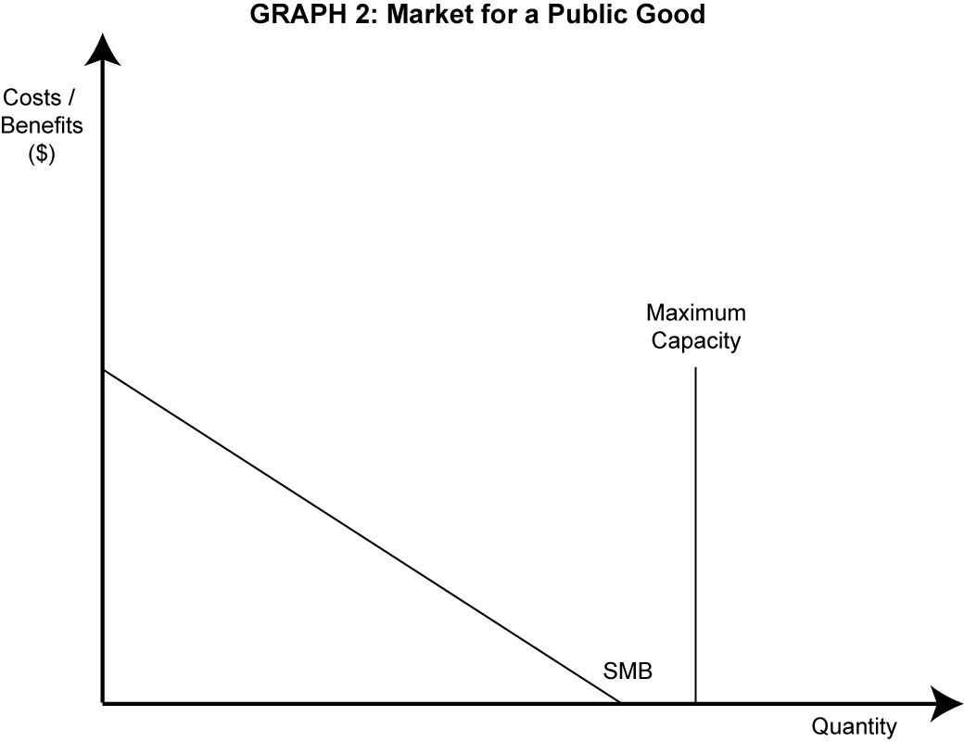

(a) On GRAPH 1 above:

(i) identify the socially desirable output level (label it **QS**).)

(ii) shade the area that represents the welfare to society from using this public good

(b) One public good in New Zealand is the Auckland Harbour Bridge. Name another public good supplied by local or central government.

________________________________________________________________________________

Using **Scenario 4** answer the following questions:

c) Adjust GRAPH 1 to illustrate **congestion** occurring on the Auckland harbor Bridge due to **increased use** as a result of North Shore growing and Auckland City becoming more densely populated. Label any curve changes

(d) Identify a **‘user pays’** charge or a **toll charge** that would stop congestion on the bridge (label it **P1**).

Two possible policies that the New Zealand Transport Authority could use to overcome congestion on the Auckland Harbour Bridge is:

**(1) to impose a user-pays charge for using the bridge**

**(2) to build a second harbour crossing transport link between Auckland City and the**

**North Shore .**

(i) Which policy would be the **most** economically efficient?

|  |
| --- |
|  |

(ii) Explain why the policy you chose in (d) (i) would be **efficient** in reducing congestion on the

Auckland Harbour Bridge

|  |
| --- |
|  |
|  |
|  |
|  |
|  |
|  |
|  |

(iii) Explain why the policy you chose in (d) (i) would be **more efficient** than the other policy.

|  |
| --- |
|  |
|  |
|  |
|  |
|  |
|  |
|  |

(e) (i) What effect do you think that charging for the use of the Auckland Harbour Bridge will have on equity?

**Increase Decrease No effect** *(Circle your prediction.)*

(ii) Explain the prediction you have just made.

|  |
| --- |
|  |
|  |
|  |
|  |
|  |

**Task sheet 9 - Lorenz Curves**

Beneficiary families will receive an extra $25 a week, after tax, from April 2016 - the centrepiece of a $240 million a year 'hardship reduction' package

v.

<http://www.radionz.co.nz/news/political/274245/budget-2015-govt-targets-child-poverty>

1. Use the data in Table 1 below to **plot** a Lorenz curve on the grid provided below. Clearly label the curve **L**1.

**Table 1 Lorenz Curve**

|  |  |  |  |  |  |  |  |  |  |
| --- | --- | --- | --- | --- | --- | --- | --- | --- | --- |
|  |  |  |  |  |  |  |  |  |  |
|  |  |  |  |  |  |  |  |  |  |
|  |  |  |  |  |  |  |  |  |  |
|  |  |  |  |  |  |  |  |  |  |
|  |  |  |  |  |  |  |  |  |  |
|  |  |  |  |  |  |  |  |  |  |
|  |  |  |  |  |  |  |  |  |  |
|  |  |  |  |  |  |  |  |  |  |
|  |  |  |  |  |  |  |  |  |  |
|  |  |  |  |  |  |  |  |  |  |

|  |  |
| --- | --- |
| **Cumulative %of Households** | **Cumulative % of Income** |
| Bottom 20 | 1 |
| 40 | 6 |
| 60 | 27 |
| 80 | 60 |
| 100 | 100 |

**2.** Explain how the Lorenz curve illustrates an **uneven distribution of income**.

|  |
| --- |
|  |
|  |
|  |
|  |
|  |
|  |
|  |
|  |
|  |

3. On the Lorenz curve above, draw a new Lorenz curve (labelled **L**2) to show the effect of introducing **higher benefit payments** to low income families.

**4**. State whether income distribution is more or less equal as a result of the **higher benefit payments.**

More Equal Less Equal [circle one]

5. Explain how an increase in **higher benefit payments** can be both equitable and inequitable?

|  |
| --- |
| Equitable: |
|  |
|  |
|  |
|  |
|  |
|  |
|  |
|  |

|  |
| --- |
| Inequitable: |
|  |
|  |
|  |
|  |
|  |
|  |
|  |

6. Higher benefit payments could result in an equity / efficiency trade-off.

1. Illustrate on Graph 2 the equity/efficiency that would occur with higher benefit payments.

**Graph 2**: Efficiency/Equity Tradeoff

Equity

A

⚫

Efficiency

(iii) Explain the impact of an increase in the higher benefit payments on **efficiency**.

|  |
| --- |
|  |
|  |
|  |
|  |
|  |
|  |
|  |
|  |
|  |
|  |

**Task sheet 10 - Lorenz Curves**

In October 2010 the New Zealand Government lowered the **top personal tax rate** for dollars earned over $70 000 from 38 cents in the dollar to 33 cents in the dollar.

**Graph 1** NZ’s Lorenz Curve Before Lowering Top Personal Tax Rate



**Cumulative % of income**

(a) Show the effect of a lower top personal tax rate on the Lorenz Curve in Graph 1 above. Label the new

curve **L1.**

(b) Choose the income tax policy you consider to be the more **equitable** intervention to improve on the

free market income distribution by circling the policy below:

Top personal tax rate of 38 cents Top personal tax rate of 33 cents

(c) **Evaluate** the **equity** of your chosen income tax policy by explaining why it would be **more effective** at producing an equitable income distribution than the other tax option.

|  |
| --- |
|  |
|  |
|  |
|  |
|  |
|  |
|  |
|  |
|  |
|  |
|  |
|  |
|  |
|  |
|  |
|  |
|  |
|  |
|  |
|  |
|  |
|  |
|  |
|  |
|  |
|  |
|  |
|  |
|  |
|  |
|  |
|  |
|  |
|  |
|  |
|  |
|  |
|  |